DSA06 - Data Handling and Visualization
Activity 6: Website Flow Sankey Design
Slot C
Name | K.L Dinesh Eshwar
Course Code | DSA0601
Course Name | Data Handling and Visualization
Reg. No | 192425027
R.No | 12
Activity | Website Flow Sankey Design
1. Scenario
The analytics team of a food-ordering app website tracked 4,260 sessions last month through four stages: traffic source, landing page, next action and outcome. The Sankey diagram shows the number of sessions on every flow, but three flows are hidden and marked with a question mark. The questions ask me to recover the hidden flows, compute some summary measures, make design decisions, size the nodes, write the R code and discuss the limits of Sankey diagrams.
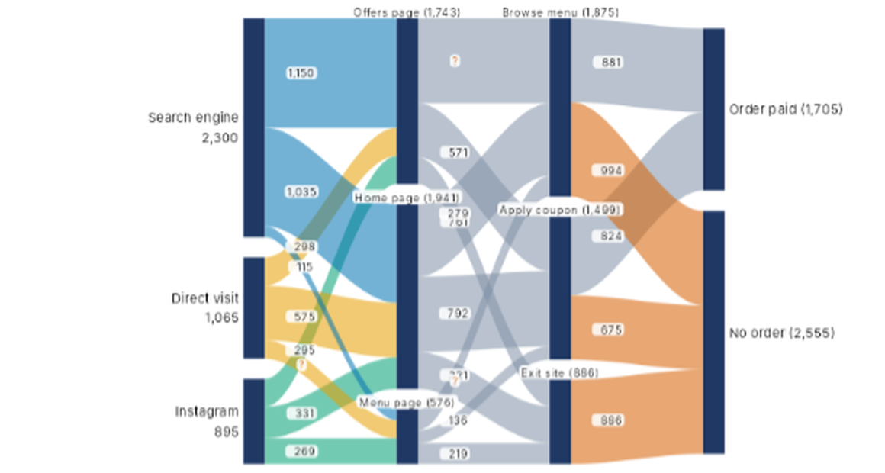
Figure 1: Sankey diagram supplied in the activity sheet (three flows marked ?)
2. Reading the diagram
Before answering, I read every visible label from the diagram and matched each flow to its source and target by the colour of the ribbon (blue = Search engine, yellow = Direct visit, teal = Instagram, grey = landing page to next action, orange = flows ending in No order). The node totals are Search engine 2,300, Direct visit 1,065 and Instagram 895 (total 4,260); Offers page 1,743, Home page 1,941 and Menu page 576; Browse menu 1,875, Apply coupon 1,499 and Exit site 886; Order paid 1,705 and No order 2,555.
2.1 Flows read from the diagram
Source | Target | Sessions | Status
Search engine | Offers page | 1,150 | Shown
Search engine | Home page | 1,035 | Shown
Search engine | Menu page | 115 | Shown
Direct visit | Offers page | 298 | Shown
Direct visit | Home page | 575 | Shown
Direct visit | Menu page | ? | Hidden
Instagram | Offers page | 295 | Shown
Instagram | Home page | 331 | Shown
Instagram | Menu page | 269 | Shown
Offers page | Browse menu | ? | Hidden
Offers page | Apply coupon | 571 | Shown
Offers page | Exit site | 279 | Shown
Home page | Browse menu | 761 | Shown
Home page | Apply coupon | 792 | Shown
Home page | Exit site | ? | Hidden
Menu page | Browse menu | 221 | Shown
Menu page | Apply coupon | 136 | Shown
Menu page | Exit site | 219 | Shown
Browse menu | Order paid | 881 | Shown
Browse menu | No order | 994 | Shown
Apply coupon | Order paid | 824 | Shown
Apply coupon | No order | 675 | Shown
Exit site | No order | 886 | Shown

3. Part (a): Hidden flows using conservation of flow [4]
Rule used: conservation of flow. At every node that is not a start or an end, the sessions that enter equal the sessions that leave, so the node value equals the sum of its incoming flows and also the sum of its outgoing flows. A hidden flow is therefore the node total minus the visible flows on the same side of that node.
3.1 Offers page to Browse menu
Offers page has a total of 1,743 sessions. Its visible outgoing flows are Apply coupon 571 and Exit site 279.
Offers page to Browse menu = 1,743 - 571 - 279 = 893 sessions.
Check at Browse menu: incoming flows are 893 (Offers) + 761 (Home) + 221 (Menu) = 1,875, which equals the node total of 1,875.
3.2 Home page to Exit site
Home page has a total of 1,941 sessions. Its visible outgoing flows are Browse menu 761 and Apply coupon 792.
Home page to Exit site = 1,941 - 761 - 792 = 388 sessions.
Check at Exit site: incoming flows are 279 (Offers) + 388 (Home) + 219 (Menu) = 886, which equals the node total of 886.
3.3 Direct visit to Menu page
Direct visit has a total of 1,065 sessions. Its visible outgoing flows are Offers page 298 and Home page 575.
Direct visit to Menu page = 1,065 - 298 - 575 = 192 sessions.
Check at Menu page: incoming flows are 115 (Search engine) + 192 (Direct visit) + 269 (Instagram) = 576, which equals the node total of 576.
3.4 Full node check
After filling in the three hidden flows, every node balances, which confirms the values and the rule.
Node | Sessions in | Sessions out
Search engine (2,300) | - | 1,150 + 1,035 + 115 = 2,300
Direct visit (1,065) | - | 298 + 575 + 192 = 1,065
Instagram (895) | - | 295 + 331 + 269 = 895
Offers page (1,743) | 1,150 + 298 + 295 = 1,743 | 893 + 571 + 279 = 1,743
Home page (1,941) | 1,035 + 575 + 331 = 1,941 | 761 + 792 + 388 = 1,941
Menu page (576) | 115 + 192 + 269 = 576 | 221 + 136 + 219 = 576
Browse menu (1,875) | 893 + 761 + 221 = 1,875 | 881 + 994 = 1,875
Apply coupon (1,499) | 571 + 792 + 136 = 1,499 | 824 + 675 = 1,499
Exit site (886) | 279 + 388 + 219 = 886 | 886
Order paid (1,705) | 881 + 824 = 1,705 | -
No order (2,555) | 994 + 675 + 886 = 2,555 | -

4. Part (b): Computations [4]
(i) Overall conversion rate
The conversion rate is Order paid as a percentage of all sessions.
Conversion rate = 1,705 / 4,260 x 100 = 40.02%.
About 4 in every 10 sessions end in a paid order. The remaining 2,555 sessions (59.98%) end without an order.
(ii) Largest single flow into No order or Exit site
The flows ending in No order are Browse menu 994, Apply coupon 675 and Exit site 886. The flows ending in Exit site are Offers page 279, Home page 388 and Menu page 219. The largest of all of these is Browse menu to No order.
Largest flow = Browse menu to No order = 994 sessions (23.33% of all sessions).
Among the flows into Exit site alone, the largest is Home page to Exit site, 388 sessions. The value 994 is notable because more than half of the sessions that reach Browse menu (994 of 1,875, which is 53.01%) leave without ordering.
(iii) Percentage of Offers page sessions that go on to Browse menu
Percentage = 893 / 1,743 x 100 = 51.23%.
About half of the visitors who see the Offers page go to the menu. For comparison, 571 of 1,743 (32.76%) go to Apply coupon and 279 (16.01%) leave the site; these three shares add to 100%.
Measure | Working | Result
Overall conversion rate | 1,705 / 4,260 | 40.02%
Largest flow into No order or Exit site | Browse menu to No order | 994 sessions
Offers page to Browse menu | 893 / 1,743 | 51.23%

5. Part (c): Four design decisions [4]
The diagram must let a manager see quickly where visitors come from and where sessions are lost. I made four design decisions, each justified in one line from the data.
Decision | What I would do | Justification (from this data)
Node order to reduce crossings | Keep Search engine at the top and place Offers page and Home page next to it. Order the next-action column as Browse menu, Apply coupon, Exit site, with Order paid above No order, and Exit site next to No order. | Offers and Home receive 2,185 of the 2,300 Search engine sessions (95%), and Exit site sends all 886 sessions to No order, so these heavy flows run almost straight.
Colour rule | Colour the first-stage ribbons by traffic source, keep the middle ribbons neutral grey, and colour the final ribbons by outcome (orange for No order). | Search engine alone brings 53.99% of sessions, so a distinct colour traces it, and orange marks the 2,555 sessions (59.98%) that are lost.
Labels | Show the name and total on every node, and show a label on a ribbon only when it has at least 200 sessions (about 5%). Show smaller flows in a tooltip. | Flows such as 115 (2.70%) and 136 (3.19%) are tiny, and the labels 279 and 761 overlap in the supplied figure.
What to highlight | Draw Browse menu to No order (994) and Exit site to No order (886) in a strong colour and mute the rest. | They are the two biggest leaks, 1,880 of the 2,555 lost sessions (73.58%), so the design points to where improvement pays most.

6. Part (d): Node heights for printing [2]
The scale is 1 cm of node height = 200 sessions, so the height in cm = sessions / 200.
Landing-page node | Working | Height
Home page | 1,941 / 200 | 9.705 cm (about 9.7 cm)
Offers page | 1,743 / 200 | 8.715 cm (about 8.7 cm)
Menu page | 576 / 200 | 2.88 cm (about 2.9 cm)

Check: 9.705 + 8.715 + 2.88 = 21.3 cm, which equals 4,260 / 200 = 21.3 cm, so the three landing-page nodes together carry all sessions on the same scale as the other stages.
7. Part (e): R code with networkD3 [4]
The code uses the networkD3 package. Nodes are numbered from 0 in the top-to-bottom order of the diagram, because sankeyNetwork() expects zero-based indices into the nodes data frame.
7.1 Nodes data frame
nodes <- data.frame(name = c(
"Search engine", # 0
"Direct visit", # 1
"Instagram", # 2
"Offers page", # 3
"Home page", # 4
"Menu page", # 5
"Browse menu", # 6
"Apply coupon", # 7
"Exit site", # 8
"Order paid", # 9
"No order" # 10
))

7.2 Links data frame for the first four flows leaving Direct visit and Instagram
In the table order of the diagram, the flows leaving Direct visit come first (to Offers page, Home page and Menu page), followed by the first flow leaving Instagram (to Offers page). The Menu page value of 192 is the hidden flow found in part (a).
links_first4 <- data.frame(
source = c(1, 1, 1, 2),
target = c(3, 4, 5, 3),
value = c(298, 575, 192, 295)
)

7.3 Complete links and the sankeyNetwork() call
To draw the whole diagram, the first four flows are joined with all the remaining flows, including the other two hidden flows (893 and 388).
library(networkD3)

links <- data.frame(
source = c(0,0,0, 1,1,1, 2,2,2,
3,3,3, 4,4,4, 5,5,5,
6,6, 7,7, 8),
target = c(3,4,5, 3,4,5, 3,4,5,
6,7,8, 6,7,8, 6,7,8,
9,10, 9,10, 10),
value = c(1150,1035,115, 298,575,192, 295,331,269,
893,571,279, 761,792,388, 221,136,219,
881,994, 824,675, 886)
)

# colour by traffic source for the first stage, outcome for the last
links$group <- c(rep("search",3), rep("direct",3), rep("insta",3),
rep("flow",9), "paid","lost", "paid","lost", "lost")
nodes$group <- "node"

cols <- 'd3.scaleOrdinal()
.domain(["search","direct","insta","flow","paid","lost","node"])
.range(["#72aed4","#f0c96b","#6fc8ae","#b8bfcc","#b8bfcc","#e8a46c","#1f3560"])'

sankeyNetwork(Links = links, Nodes = nodes,
Source = "source", Target = "target", Value = "value",
NodeID = "name", LinkGroup = "group", NodeGroup = "group",
colourScale = cols, units = "sessions",
fontSize = 13, nodeWidth = 20, nodePadding = 14,
sinksRight = TRUE)

If plotly is preferred, the same links and nodes can be passed to plot_ly(type = "sankey", node = list(label = nodes$name), link = list(source = links$source, target = links$target, value = links$value)).

8. Part (f): When a Sankey diagram misleads [2]
Situation | Why the Sankey fails | Alternative chart
Too many nodes and flows (for example 50 different pages or hundreds of product paths) | Ribbons cross in every direction, labels collide and the picture becomes unreadable spaghetti. Thin ribbons cannot be told apart. | A heat map of the transition matrix (source in rows, target in columns, colour = sessions), or a bar chart of the top 10 paths.
Users can go back or loop (for example Menu page to Home page and back), or exact values must be compared between stages | A Sankey must flow in one direction and cannot show cycles. Widths are also hard to compare precisely and can exaggerate or hide small differences. | A network (state-transition) diagram for loops, or a funnel chart or grouped bar chart when the aim is to compare exact stage-to-stage conversion.

Two further cautions for this data set are that the colour of a ribbon should not change the meaning of its width, and that a Sankey shows how many sessions flow but not why they leave, so it should be read together with the reasons from user research.
9. Summary of answers
Part | Answer
(a) | Offers to Browse menu = 893; Home to Exit site = 388; Direct visit to Menu page = 192. Rule: conservation of flow (inflow = outflow at each node).
(b) | (i) 40.02%; (ii) 994 (Browse menu to No order); (iii) 51.23%.
(c) | Order nodes by main flows to cut crossings; colour by source then outcome; label only flows of 200 or more; highlight the 994 and 886 flows to No order.
(d) | Home page 9.705 cm; Offers page 8.715 cm; Menu page 2.88 cm.
(e) | nodes data frame (11 nodes), links data frame from source, target and value, drawn with networkD3::sankeyNetwork().
(f) | Too many nodes (use a heat map); loops or exact comparison (use a network diagram or funnel chart).

